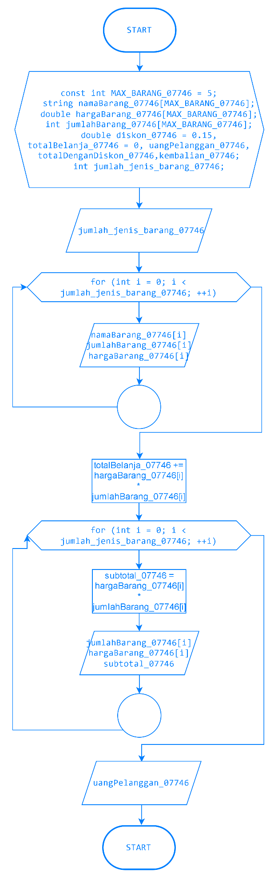

#include <iostream>

using namespace std;

int main() {

const int MAX_BARANG_07746 = 5;

string namaBarang_07746[MAX_BARANG_07746];

double hargaBarang_07746[MAX_BARANG_07746];

int jumlahBarang_07746[MAX_BARANG_07746];

double diskon_07746 = 0.15, totalBelanja_07746 = 0, uangPelanggan_07746, totalDenganDiskon_07746,kembalian_07746;

int jumlah_jenis_barang_07746;

cout << "---------------------------------------------------\n";

cout << "--------------- K A S I R I T A T S ---------------\n";

cout << "---------------------------------------------------\n";

cout << "Masukkan jumlah jenis barang: ";

cin >> jumlah_jenis_barang_07746;

cout << "-----------------------------" << endl;

for (int i = 0; i < jumlah_jenis_barang_07746; ++i) {

cout << "Masukkan barang ke-\n" << i + 1 <<endl;

cout << "Nama barang : ";

cin >> namaBarang_07746[i];

cout << "Jumlah : ";

cin >> jumlahBarang_07746[i];

cout << "Harga barang per unit : ";

cin >> hargaBarang_07746[i];

totalBelanja_07746 += hargaBarang_07746[i] * jumlahBarang_07746[i];

cout << "-----------------------------\n";

}

cout <<"\n====================================================\n";

cout <<"=========== Struk Pembelian Kasir ITATS ============\n";

cout <<"====================================================\n";

cout << "No Barang Jumlah Harga Subtotal" << endl;

for (int i = 0; i < jumlah_jenis_barang_07746; ++i) {

double subtotal_07746 = hargaBarang_07746[i] * jumlahBarang_07746[i];

cout << i + 1 << " " << jumlahBarang_07746[i] << " Rp." << hargaBarang_07746[i] << " Rp." << subtotal_07746 << endl;

}

cout <<"====================================================\n";

totalDenganDiskon_07746 = totalBelanja_07746 - (totalBelanja_07746 * diskon_07746);

cout << "SELAMAT ANDA MENDAPATKAN DISKON 15%"<<endl;

cout << "Jumlah Bayar : Rp " << totalBelanja_07746 << endl;

cout << "Diskon : Rp " << totalBelanja_07746 * diskon_07746 << endl;

cout << "Total Bayar : Rp " << totalDenganDiskon_07746 << endl;

cout << "Bayar : Rp ";

cin >> uangPelanggan_07746;

kembalian_07746 = uangPelanggan_07746 - totalDenganDiskon_07746;

cout << "Kembalian : Rp " << kembalian_07746 << endl;

cout << "-----------------------------\n";

return 0;

}

